|  |
| --- |
| **Exercise** |

**Exercise 1**



Write a Python program to replace the last element in a list with another list.

Expected output:

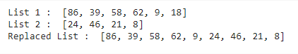

**Code:**

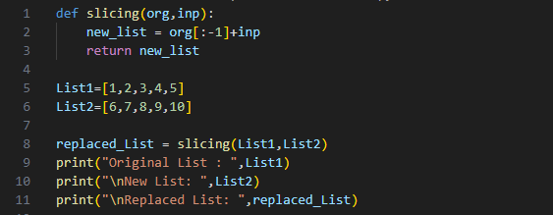

**Output**:

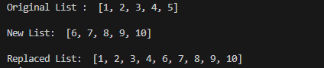

**Exercise 2**



Write a Python program to get a string made of the first 2 and the last 2 chars from a given a string. If the string length is less than 2, return instead of the empty string

Expected output:

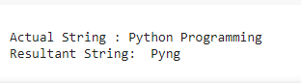

**Code:**

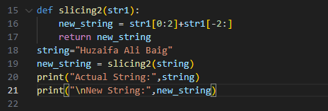

**Output:**



**Exercise 3**



Write a python program that takes three dictionaries as input (user or static) and concatenates them into one dictionary, and prints it.

Expected output:

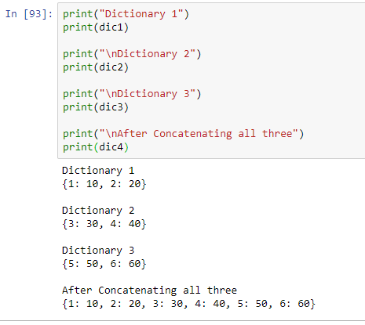

**Code:**

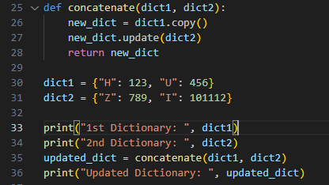

**Output:**



**Exercise 4**



Create a python program that takes user input and prints square, square root of that number, number powered to 3 (num^3).

Expected output:

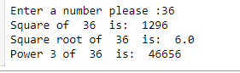’

**Code:**

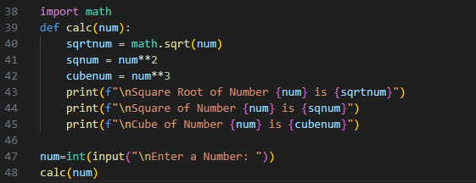

**Output:**

